

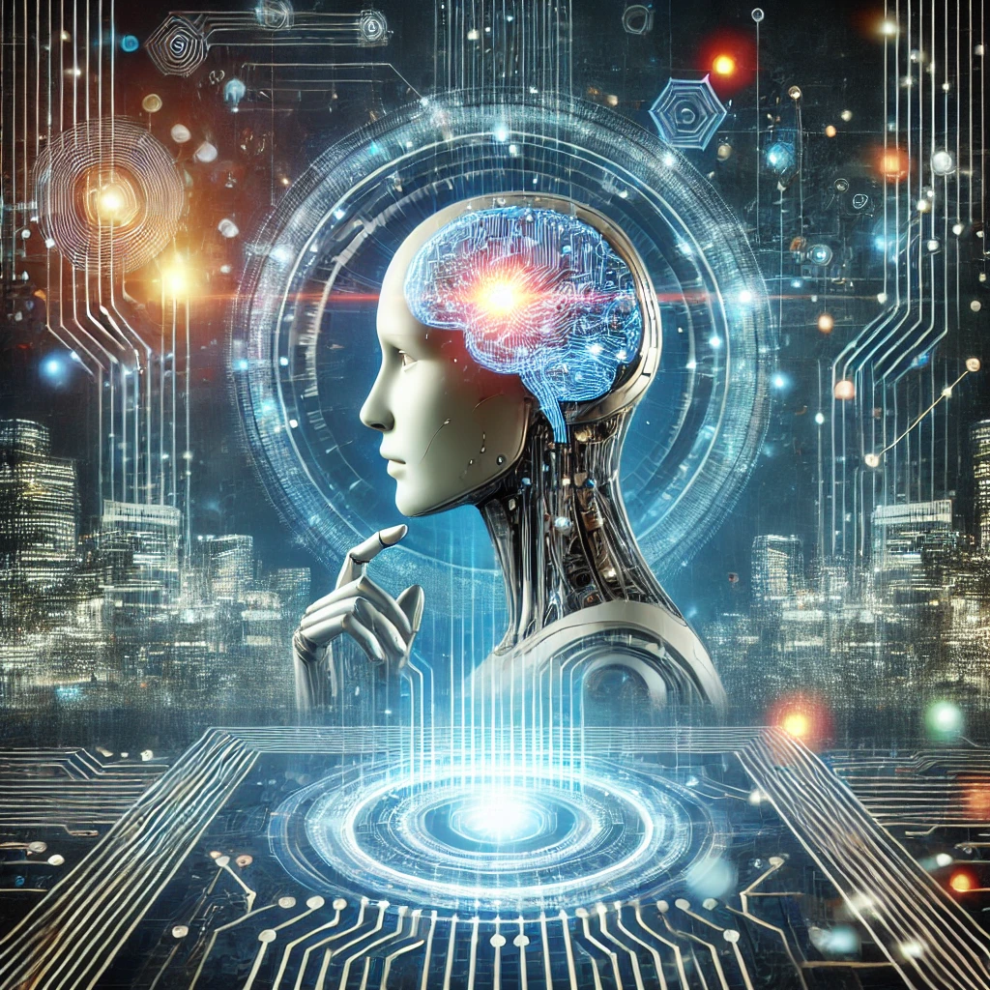

- Student name: omar Abuhassan
- Student ID Number: 22110264
- Major: Data Science and Artificial Intelligence
- Academic Year: 3rd
- Course Tutor: Batool Alarmouti

Compare the advantages and challenges of several tools and techniques for the development of Intelligent Systems.
Technique/Tool | Advantages | Challenges | Example Use Cases
Knowledge-Based Systems | Has a high ability to interpret simply in addition to rapid modeling | Expansion and knowledge acquisition are difficult to carry out | Troubleshooting and fixing errors
Machine Learning | High adaptability, automatic learning and rapid prototyping | Long execution time, overly data-driven | Classification and compilation
Fuzzy Logic | The great similarity between it and human logic, flexibility and simplicity | Limited learning, complex expansion process | Control Systems and Decision-Making Processes
Swarm Intelligence | Scalability and improvement | Complex design and high costs | Logistics Software & Robotics
Reinforcement Learning | Self-learning and generalization | Exploration and exploitation barter | Robotics & Games

Investigate options around approaches, techniques and tools for the deployment of modern Intelligent Systems
1. Methods of deployment
The deployment of AI systems is classified according to system requirements and system infrastructure.
1.1. Cloud-based deployment:
The AI system is deployed on cloud platforms such as AWS, Microsoft Azure, Google Cloud
This method is characterized by scalability on demand, and low cost as this method works according to payment models, in addition to saving system uptime with distributed data centers
On the other hand, there are challenges facing this method.
It takes a long time to respond based on internet speed
In addition, the data must comply with the regulatory standards regulation.
1.2. Edge deployment
It relies on deploying systems directly on peripherals such as phones and IoT sensors.
This method is characterized by processing data directly, so it does not depend on the speed of the Internet, and since it processes data immediately, it maintains the privacy of devices and sensitive data.
On the other hand, it faces some challenges, such as the power in computing devices is less than the power in the cloud, which needs to be updated simultaneously.
1.3 Hybrid deployment
A method that combines the previous two methods where cloud deployment and the edge are combined, and this allows distributed processing
This method is characterized by a balance of performance, as operations that need intensive operations are run in the cloud way, while the important is run in real time.
In addition to dynamic conversion between cloud and edge method
On the other hand, some challenges may limit these features.
The integration of the two methods requires smooth interaction and this topic can be difficult.
2.Deployment techniques
2.1 Containers
The system is clustered into containers using tools such as Docker Kubernetes.
This technology is characterized by portability, as it enables containers to be transported easily in addition to operating the system in isolation from other applications
The possibility of expanding the range of systems saved in containers automatically
On the other hand, there are some challenges that may limit the work to the highest efficiency.
Containers consume additional resources and require familiarity with coordination tools.

2.2 Model optimization
Reduces the size and complexity of models by trimming and quantization
Reduced memory and computing requirements as well as allowing deployment on low-power devices
On the other hand, there are challenges of this technology.
It may lead to a loss of accuracy due to optimization.
This technique requires great effort and knowledge of specialized tools and a lot of knowledge and experience
2.3 Integration and continuous deployment
This technology automates testing, deployment and integration processes.
It features reduced manual errors in deploying challenges and ensures smooth non-stop updates
As for the challenges
They require strong pipelines and supplies, which can lead to updated emissions that cause compatibility issues.
Investigating deployment options for modern intelligent systems involves understanding the methods, techniques, and tools that ensure effective implementation, scalability, and maintenance. Here is a detailed analysis:
3. Deployment tools
A variety of tools are available to support the deployment of intelligent systems:

3.1 Cloud platforms
- Amazon Web Services (AWS):
It offers tools like SageMaker for training and deploying machine learning models.
Integrated with Lambda for serverless deployment.
- Microsoft Azure:
Azure Machine Learning to deploy and monitor the model.
Integration with IoT Hub for edge deployment.
- Google Cloud:
AI platform for end-to-end machine learning workflows.
TensorFlow Extended (TFX) for scalable deployment.
3.2 Container tools
Dokker, It facilitates the process of creating the container and ensures transportability.
Copernets Manages containerized applications, provides scalability and fault tolerance.
3.3 Frameworks for model optimization
TensorFlow Lite Optimized for mobile and built-in devices.
ONNX (Open Neural Network Exchange) provides interoperability across different deep learning frameworks.
PyTorch Mobile It allows the deployment of PyTorch models on mobile devices.
3.4 Monitoring and management tools
Prometheus Monitor the health and performance of published systems.
Gravana, It visualizes metrics and provides real-time dashboards.
MLflow Tracks model versions, performance, and deployment logs.
Aspect | Cloud-Based | Edge Deployment | Hybrid Deployment
Latency | Moderate | Low | Moderate to Low
Scalability | High | Limited | High
Cost | Pay-as-you-go | Initial hardware cost | Balanced
Privacy | Relies on cloud security | Local data processing | Balanced
Use Cases | Large-scale systems | IoT devices, real-time analytics | Dynamic and distributed systems

Evaluate the potential impact of deploying several types, approaches and tools of AI and Intelligent Systems on both users and organizations
1. Types of artificial intelligence and intelligent systems
1.1 Predictive systems (e.g., fraud detection, predictive maintenance)
- Users:
- Positive Impact:
Increase security and trust (for example, fraud detection systems alert users to any suspicious activity).
Improve user experience by proactively resolving issues.
- Negative impact:
False positives can annoy users (for example, marking legitimate transactions as fraud).
A lack of transparency can erode trust in the system.

- Organizations:
- Positive Impact:
Save costs by detecting problems early (for example, avoiding equipment failure).
Enhance decision-making with data-driven insights.
- Negative impact:
Requires high-quality data for reliable forecasts.
Initial implementation costs may be high.

1.2 Autonomous systems (e.g., self-driving cars, robotics)
- Users:
- Positive Impact:
Increased comfort (e.g., self-driving vehicles reduce the need to drive).
Enhance safety in hazardous environments (e.g., robots in construction or mining).
- Negative impact:
Users may fear loss of control or accidents caused by system errors.
Ethical concerns about decision-making in critical situations.

- Organizations:
- Positive Impact:
Efficiency gains and reduced operational costs (e.g., autonomous delivery robots).
Competitive advantages through innovation.
- Negative impact:
Concerns about liability in the event of accidents.
Resistance from the workforce for fear of losing a job.

1.3 Recommendation systems (e.g., Netflix, Amazon)
- Users:
- Positive Impact:
Personal experience increases satisfaction and engagement.
Saves time by narrowing down options.
- Negative impact:
Users may feel that they are being manipulated by targeted suggestions.
Over-reliance may reduce user autonomy.

- Organizations:
- Positive Impact:
Increase revenue by improving customer retention and sales.
Better understanding of customer preferences.
- Negative impact:
Incompatible recommendations can lead to customer dissatisfaction.
Privacy concerns regarding the collection of user data.

2. Deployment methods
2.1 Top-down approach
- Users:
- Positive Impact:
Provides reliable and well-organized systems.
Clearly defined rules guarantee transparency and fairness.
- Negative impact:
Limited ability to adapt to the user's unique needs or preferences.
Slow response to rapidly changing requirements.

- Organizations:
- Positive Impact:
Easier to manage and document.
Reduces the risk of execution errors.
- Negative impact:
Rigid systems may have difficulty expanding or integrating with cutting-edge technologies.

2.2 Bottom-up approach
- Users:
- Positive Impact:
Adaptive systems provide customized solutions based on user behavior.
Continuous improvement enhances user satisfaction over time.
- Negative impact:
Users may encounter some discrepancies during the learning phase of the system.
Less predictable behavior can lead to confusion or mistrust.

- Organizations:
- Positive Impact:
Flexible and scalable systems that evolve with the needs of the organization.
Supports innovation through data-driven learning.
- Negative impact:
Higher upfront costs and longer development schedules.
Risk of unintended results or biases in the system.

3. Tools for AI deployment
3.1 Cloud platforms (for example, AWS, Azure, Google Cloud)
- Users:
- Positive Impact:
High availability provides uninterrupted service.
Fast processing speeds improve response times.

- Negative impact:
Relying on an Internet connection may cause inconvenience to users.
Privacy concerns personal data stored on the cloud.
- Organizations:
- Positive Impact:
Simplifies the deployment process with ready-to-use tools.
Easily fits into organizational growth.
- Negative impact:
Long-term costs can accumulate due to subscription-based models.
A potential vendor's monopoly reduces flexibility.

3.2 Edge deployment (e.g., TensorFlow Lite, PyTorch Mobile)
- Users:
- Positive Impact:
Lower latency improves real-time interactions.
Increase privacy where data is processed locally.
- Negative impact:
Limited features compared to cloud systems.
Users may need to upgrade hardware to support edge systems.

- Organizations:
- Positive Impact:
Reduces reliance on cloud infrastructure, resulting in lower costs.
Allows deployment to remote locations with limited connectivity.
- Negative impact:
Hardware restrictions may restrict functionality.
System updates are difficult to deploy across distributed devices.

4. Co-impact on users and organizations
- Users
- Benefits:
Improve decision-making with predictive analytics.
Personalized and adaptive experiences increase satisfaction.
Enhance safety and comfort in various fields.
- Challenges:
Concerns about data privacy and system transparency.
Over-reliance on smart systems may reduce user autonomy.
The risk of alienation if systems fail to meet expectations.
- Organizations
- Benefits:
Cost savings and operational efficiency through automation.
Competitive advantage by leveraging advanced tools and technologies.
Get better insights into customer behavior for strategic planning.
- Challenges:
High initial costs and ongoing maintenance requirements.
Ethical and legal hazards associated with biased or flawed systems.
Resistance by employees due to fears of losing a job.

